Software Architecture and Design Specification
Online Exam Portal
Version: 1.0
Authors: Rehan S Bawakhan (CS820) · Yeshaswinie D (CS619) · Yashwantha R (CS614) · Yashaswini Singh (CS612)
Date: 14-09-2026
Status: Draft
Derived from: Online Exam Portal SRS, Version 1.0 (05-09-2026)

Revision History
Version | Date | Author | Change Summary
1.0 | 14-09-2026 | Rehan S Bawakhan, Yeshaswinie D, Yashwantha R, Yashaswini Singh | Initial SAD draft, derived from Online Exam Portal SRS v1.0 following the course SAD template.

Approvals
Role | Name | Signature / Date
Course Coordinator | Prof. Pavithra | Pending

1. Introduction

1.1 Purpose
This document specifies the software architecture and detailed design of the Online Exam Portal. It translates the functional and non-functional requirements captured in the Online Exam Portal SRS (v1.0) into a concrete system structure — component layout, chosen architecture pattern, technology stack, security architecture, interaction flows and API design — so that developers, QA and reviewers share a single technical reference for how the system is built, not just what it must do.

1.2 Scope
This SAD covers the architecture and design of every module described in the SRS: authentication & access control, question bank management, exam creation & scheduling, online exam delivery, evaluation & grading, result processing & reporting, and administration/monitoring — for the three user roles Admin, Faculty and Student. Consistent with the SRS, a native mobile app, a payment gateway, and camera/biometric proctoring remain out of scope for this version.

1.3 Audience
Developers, QA engineers, security reviewers, the project guide/course coordinator, and future maintenance teams.

1.4 Definitions
Term | Meaning
SRS | Software Requirements Specification
Admin | System administrator who manages the portal as a whole
Faculty / Examiner | Creates exams and question banks, grades subjective answers
MCQ | Multiple Choice Question
UI / API | User Interface / Application Programming Interface
FR / NFR | Functional Requirement / Non-Functional Requirement
RTM | Requirements Traceability Matrix
OTP | One-Time Password
TLS | Transport Layer Security
WCAG | Web Content Accessibility Guidelines
RBAC | Role-Based Access Control
REST | Representational State Transfer (architectural style for the APIs)
ADR | Architecture Decision Record
STRIDE | Spoofing, Tampering, Repudiation, Information disclosure, Denial of service, Elevation of privilege — threat-modeling categories

2. Document Overview

2.1 How to use this document
This document provides the architectural and design deliverables for the Online Exam Portal: a layered component diagram, two UML sequence diagrams covering the core student and faculty flows, a STRIDE-based threat model, REST API definitions for the core services, and a traceability mapping back to the SRS requirement IDs.

2.2 Related Documents
- Online Exam Portal SRS, Version 1.0 (05-09-2026)
- Software Test Plan (STP) — to be derived from Section 6 of the SRS
- Requirements Traceability Matrix (RTM) — Section 8 of the SRS

3. Architecture

3.1 Goals & Constraints
Goals:
- Secure — protect student credentials, exam questions and answer keys at every stage.
- Reliable — no submitted or in-progress exam response is ever lost (OEP-NF-002).
- Available — the portal stays up at least 99% of the time during scheduled exam windows (OEP-NF-003).
- Performant — routine actions complete within 2 seconds at the 90th percentile with 200 concurrent exam-takers (OEP-NF-001).
- Accessible — usable by a first-time student unaided; meets WCAG 2.1 AA where practical (OEP-NF-005).
- Maintainable & scalable — UI, business logic and data-access code stay in separate, independently scalable modules (OEP-NF-006).
Constraints:
- Browser-only client — no installed plugins or a native app.
- Standard web/app server stack agreed for the course (Node.js, Django or Spring Boot) with a MySQL/PostgreSQL database.
- Must remain usable over a slow or unstable student connection.
- Student data and exam records must follow the institution's data-privacy and academic-integrity rules.
- Must be buildable within the timeframe and tech stack agreed for this course project.

3.2 Stakeholders & Concerns
Stakeholder | Concerns
Students | Exam integrity, a fair and accurate timer, no answer loss, privacy of personal and academic data.
Faculty / Examiner | Fast question and exam authoring, a manageable subjective-grading workload, accurate class-level analytics.
Admin | User and course administration, visibility into system health, a reliable audit trail.
Course coordinator / evaluators | Traceability back to the SRS, alignment with IEEE 42010, WCAG and OWASP practice.
Developers | Clear module boundaries and API contracts, testability, straightforward maintenance.

3.3 Component (UML) Diagram
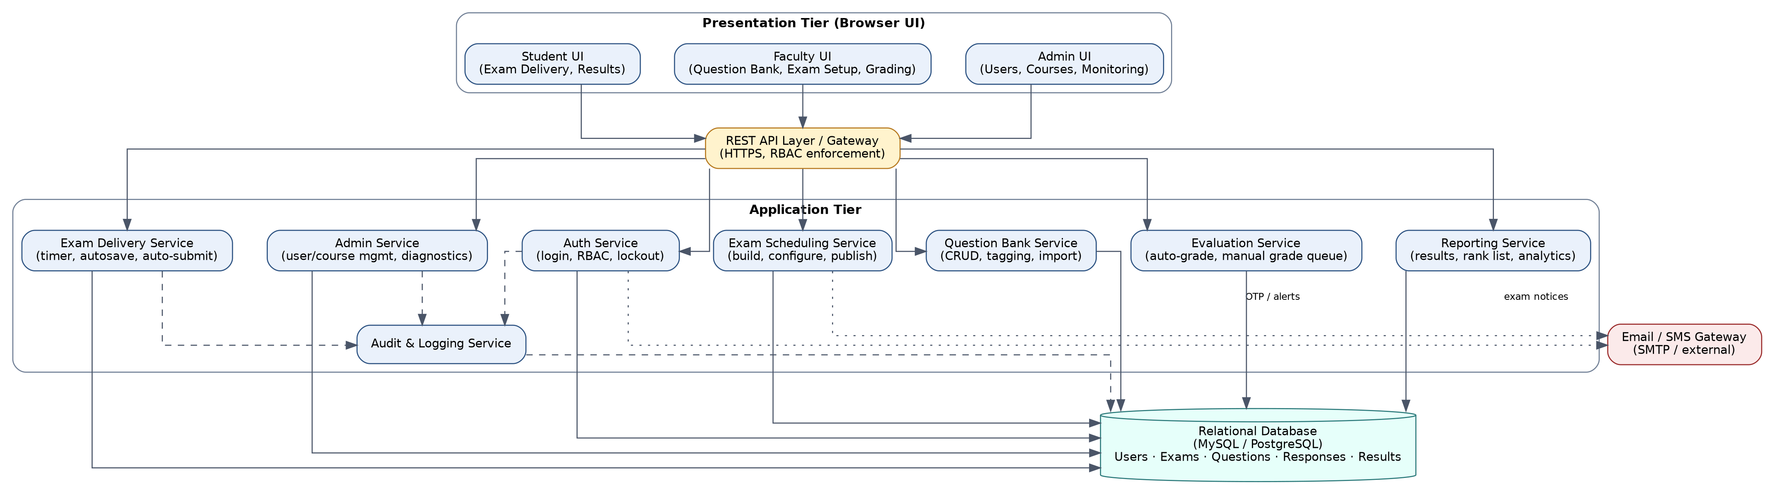
Figure 1: Component Diagram — Online Exam Portal (three-tier, modular application layer)

3.4 Component Descriptions
- Student / Faculty / Admin UI — browser-based, role-specific screens: login, dashboards, question bank, exam-creation wizard, the exam-taking screen (question navigator, timer, submit), and the results/analytics dashboard.
- REST API Layer / Gateway — the single HTTPS entry point; enforces authentication and role-based access control on every endpoint before a request reaches a service.
- Auth Service — registration, login, password hashing, account lockout after repeated failures, session/token issuance.
- Question Bank Service — CRUD and tagging for questions (subject, topic, difficulty), CSV/Excel bulk import, and an edit-lock once a question is attached to a live or published exam.
- Exam Scheduling Service — exam assembly (hand-picked or rule-based), configuration of duration/marks/negative-marking, the availability window, group/course assignment, and publish/unpublish.
- Exam Delivery Service — serves the exam to the student, keeps a server-authoritative countdown, accepts periodic autosave, enforces the single-attempt rule, and auto-submits on timeout.
- Evaluation Service — auto-grades objective answers on submission, routes subjective answers to a Faculty grading queue, and computes the final score once grading is complete.
- Reporting Service — per-student scorecards, class/course analytics, rank lists, question-wise breakdowns, and PDF/Excel export.
- Admin Service — user/course/account management, system-wide log review, and a health-diagnostics panel.
- Audit & Logging Service — a central, append-only log of logins, submissions, evaluation changes and integrity flags, retained per OEP-NF-004.
- Relational Database — stores users, exams, questions, responses and results (MySQL or PostgreSQL).
- Email / SMS Gateway — external notification channel (SMTP/SMS) used for OTPs and exam notices.

3.5 Chosen Architecture Pattern and Rationale
A layered, three-tier architecture (presentation / application / data) is chosen, with the application tier organized as a set of cohesive, independently testable modules — Auth, Question Bank, Scheduling, Delivery, Evaluation, Reporting and Admin — sitting behind a single REST API gateway; effectively a modular monolith. This gives a clean separation of concerns and satisfies OEP-NF-006 (independently maintainable modules capable of scaling out) without the operational overhead a full microservices split would add for a course-scale, single-institution deployment. Microservices were considered and rejected for the same reason the reference ATM example rejects them: the team size, timeline and expected load don't justify the added deployment and monitoring complexity. The module boundaries chosen here would, however, map cleanly onto separate services later if the project continues past this course.

3.6 Technology Stack & Data Stores
- Backend: Node.js, Django or Spring Boot (per SRS §2.4), exposing REST APIs over HTTPS.
- Database: MySQL or PostgreSQL — a relational schema for users, exams, questions, responses and results.
- Real-time sync: WebSocket (with polling fallback) to keep the exam countdown synchronized with the server clock.
- Notifications: SMTP-based email/SMS gateway.
- Client: any modern browser (Chrome, Firefox, Edge) on Windows, Linux, macOS, Android or iOS — no installed plugins.
- Security: TLS 1.2+, bcrypt/Argon2 password hashing, server-side RBAC checks on every endpoint.

3.7 Risks & Mitigations
Risk | Mitigation
Student loses connection mid-exam and responses are lost. | Periodic server-side autosave (OEP-F-035) plus an idempotent submit endpoint.
Client-side timer is spoofed or drifts from the true deadline. | Timer authority lives on the server; the client only displays a synchronized countdown (OEP-F-030).
High concurrent load during a scheduled exam window. | Stateless application layer designed to scale horizontally, with DB connection pooling; load-tested for 200 concurrent users (OEP-NF-001, OEP-NF-006).
Exam questions or answer keys leak through the client. | Answer keys are never serialized into client-side code or API responses before or during the exam window (OEP-SR-004).
Subjective grading becomes a bottleneck for Faculty. | A dedicated per-exam grading queue; final results are released only after grading completes.
Single database instance is a single point of failure. | Scheduled backups and, for a production deployment, a read replica / failover configuration.
Repeated login attempts (credential stuffing). | Account lockout after 5 consecutive failed attempts, with the event written to the audit log (OEP-F-004, OEP-SR-005).

3.8 Traceability to Requirements
Requirement Group | Component
OEP-F-001 – OEP-F-004 (Authentication & Access Control) | Auth Service
OEP-F-010 – OEP-F-013 (Question Bank Management) | Question Bank Service
OEP-F-020 – OEP-F-024 (Exam Creation & Scheduling) | Exam Scheduling Service
OEP-F-030 – OEP-F-035 (Online Exam Delivery) | Exam Delivery Service
OEP-F-040 – OEP-F-043 (Evaluation & Grading) | Evaluation Service
OEP-F-050 – OEP-F-053 (Result Processing & Reporting) | Reporting Service
OEP-F-060 – OEP-F-063 (Administration & Monitoring) | Admin Service
OEP-NF-004 (Audit / Retention) | Audit & Logging Service
OEP-SR-001 – OEP-SR-006 (Security requirements) | REST API Layer, Auth Service, Exam Delivery Service (see §3.9)

3.9 Security Architecture
Threat Modeling (STRIDE):
Threat | Mitigation | Related Requirement(s)
Spoofing | Hashed credentials (bcrypt/Argon2), server-issued session tokens, unique email/roll-number registration. | OEP-F-001, OEP-F-002, OEP-SR-002
Tampering | Server-side RBAC on every endpoint; questions are locked from editing once attached to a live/published exam. | OEP-F-003, OEP-F-013, OEP-SR-006
Repudiation | Append-only audit log of logins, submissions, evaluation changes and integrity flags, retained ≥1 academic year. | OEP-F-004, OEP-NF-004
Information Disclosure | TLS 1.2+ on all traffic; answer keys withheld from the client until after the exam window closes. | OEP-SR-001, OEP-SR-004
Denial of Service | Rate limiting on authentication endpoints, account lockout after 5 failed attempts, horizontally scalable application tier. | OEP-F-004, OEP-SR-005, OEP-NF-006
Elevation of Privilege | Role checks are enforced at the server/API layer for every endpoint — never only hidden in the client UI. | OEP-F-003, OEP-SR-006

4. Design

4.1 Design Overview
The Online Exam Portal is designed as the layered modules described in Section 3, each exposed through a small set of REST endpoints behind the API gateway. The two flows most central to the system — a student's exam attempt and a Faculty member's exam-authoring/grading cycle — are detailed as UML sequence diagrams below; the remaining flows (registration, admin user management, reporting) follow the same request → service → database pattern.

4.2 UML Sequence Diagrams
Two sequence diagrams are included below, covering the two flows most specific to this project: a student taking and submitting a timed exam, and a Faculty member creating, publishing and grading one.
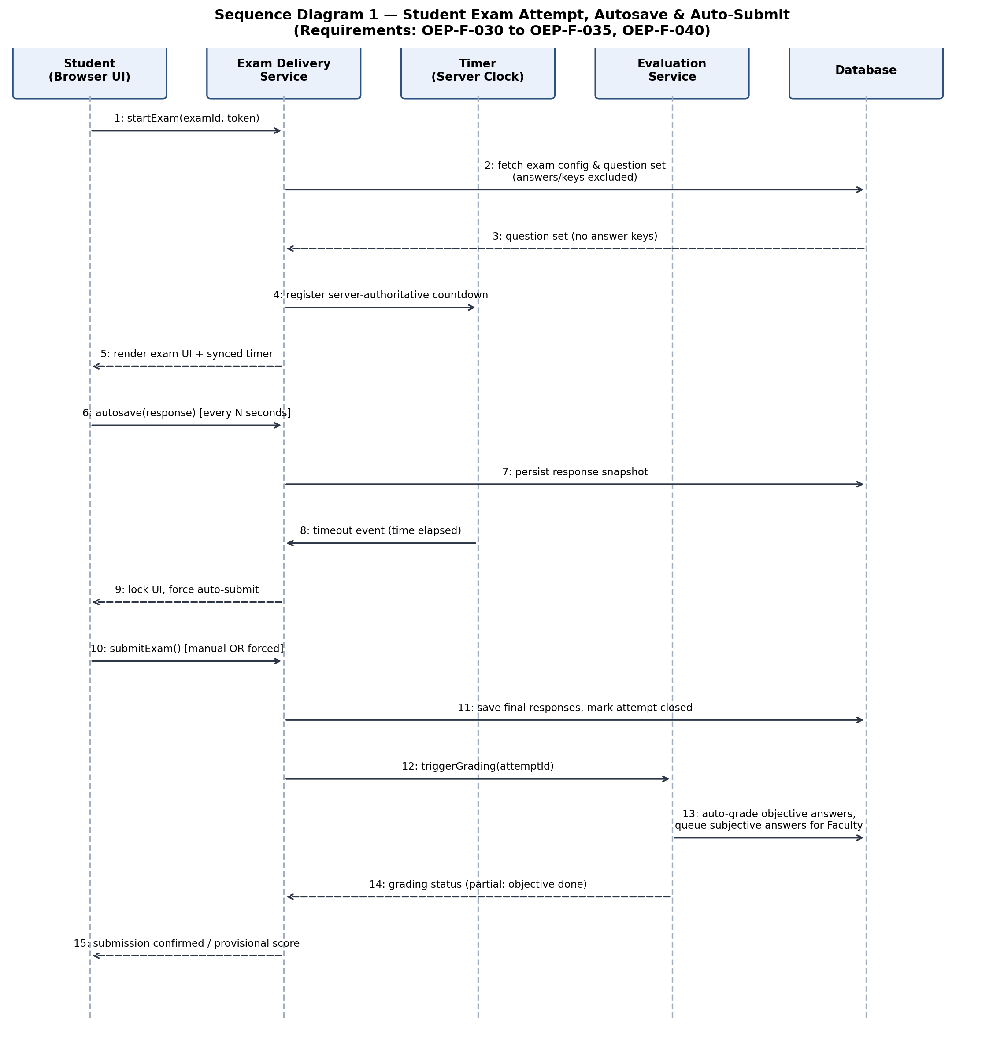
Figure 2: Sequence Diagram — Student Exam Attempt, Autosave & Auto-Submit (OEP-F-030 to OEP-F-035, OEP-F-040)
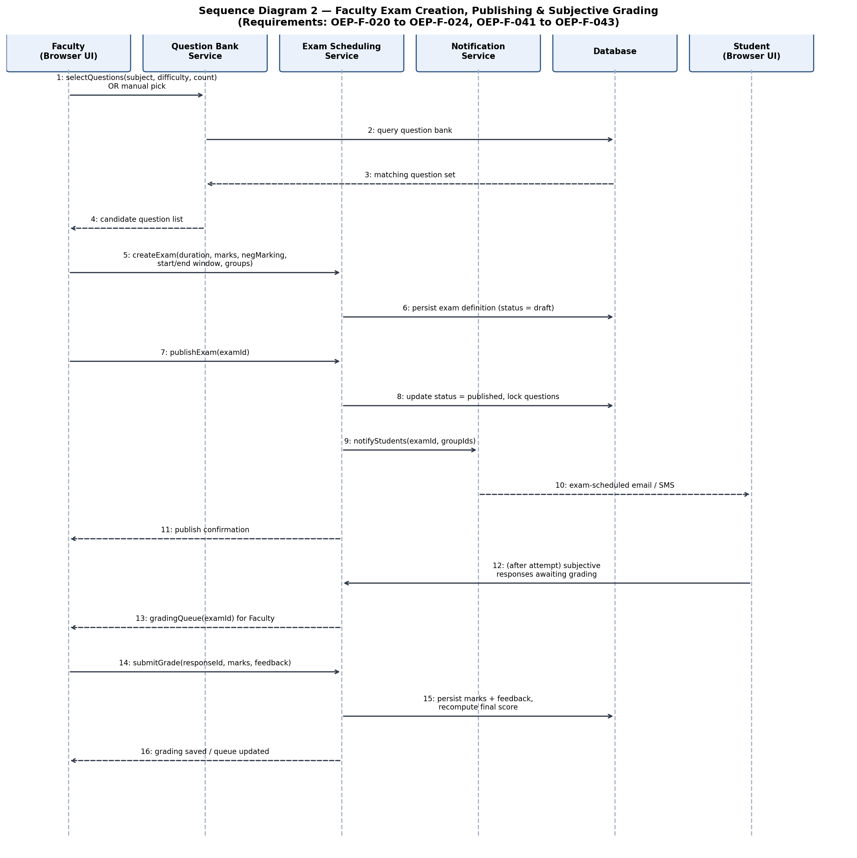
Figure 3: Sequence Diagram — Faculty Exam Creation, Publishing & Subjective Grading (OEP-F-020 to OEP-F-024, OEP-F-041 to OEP-F-043)

4.3 API Design
Interface definitions are given for three components: Auth Service, Exam Delivery Service and Evaluation Service.

Auth Service
Endpoint: /api/auth/register
Method: POST
Request: { name, email or rollNo, password, role }
Response: { status, userId }
Errors: 409 Email/roll number already registered · 422 Password does not meet policy
Endpoint: /api/auth/login
Method: POST
Request: { email, password }
Response: { status, token, role, expiresIn }
Errors: 401 Invalid credentials · 423 Account locked (5 consecutive failed attempts)

Exam Delivery Service
Endpoint: /api/exams/{examId}/start
Method: POST
Request: { studentId, token }
Response: { status, attemptId, questions[], serverTime, endsAt }
Errors: 403 Exam not in window / already attempted · 401 Invalid token
Endpoint: /api/exams/{examId}/attempts/{attemptId}/autosave
Method: PUT
Request: { responses[] }
Response: { status, savedAt }
Errors: 410 Attempt already closed · 401 Unauthorized
Endpoint: /api/exams/{examId}/attempts/{attemptId}/submit
Method: POST
Request: { responses[], reason: "manual" | "timeout" }
Response: { status, submittedAt }
Errors: 410 Attempt already submitted

Evaluation Service
Endpoint: /api/attempts/{attemptId}/grade
Method: POST
Request: { responseId, marks, feedback }
Response: { status, updatedScore }
Errors: 403 Not the assigned grader · 422 Marks exceed the question's maximum

4.4 Error Handling, Logging & Monitoring
All services return a standardized JSON error envelope — { status, errorCode, message } — using the HTTP status codes shown in Section 4.3. No passwords, tokens or answer content are ever written to logs; only IDs, timestamps and event types are recorded, consistent with OEP-SR-002. The Audit & Logging Service captures logins, submissions, evaluation changes and admin actions. Monitoring dashboards track the 90th-percentile response time, the number of concurrent active exam sessions, the auto-submit success rate and latency (target ≤2 seconds of expiry, per OEP-F-032), the failed-login rate, and overall server/database health — the last of these surfaced to Admin through the diagnostics panel (OEP-F-063).

4.5 UX Design
- A distraction-minimized exam-taking screen: question navigator, an always-visible synced countdown, flag-for-review, and a single submit action with a confirmation step.
- Meets WCAG 2.1 AA where practical: sufficient color contrast, resizable and legible fonts, full keyboard navigation, and descriptive labels for screen readers (OEP-NF-005).
- A responsive layout so the same screens work on desktop, laptop and mobile browsers without a native app.
- A clear autosave indicator so students can see their answers are being saved as they work.
- Role-specific dashboards keep Admin, Faculty and Student each limited to the stats and shortcuts relevant to their role (SRS §3.1).

4.6 Open Issues & Next Steps
- Camera/biometric-based proctoring — explicitly out of scope for this version (SRS §1.2).
- A native mobile app.
- Payment gateway integration, should the portal extend to paid or certification exams.
- Adaptive question difficulty and AI-assisted subjective grading, as possible future enhancements.

5. Appendices

5.1 Glossary
SRS, Admin, Faculty/Examiner, MCQ, UI/API, FR/NFR, RTM, OTP, TLS, WCAG, RBAC, REST, ADR, STRIDE — see the Definitions table in Section 1.4 for full expansions.

5.2 References
- IEEE 42010 — Systems and software engineering: Architecture description
- OWASP Top 10 / Application Security Verification Standard (ASVS)
- NIST SP 800-160 — Systems Security Engineering
- WCAG 2.1 (Level AA) — Web Content Accessibility Guidelines
- Online Exam Portal SRS, Version 1.0 (05-09-2026)

5.3 Tools
- Graphviz and draw.io — architecture and component diagrams
- Swagger / OpenAPI — API design and documentation
- Postman — API testing
- MySQL Workbench / pgAdmin — database design

